Score:
Judge:
Possible 10 pts
ROUND 1
Team: Scribe:
- The American Revolution ended with the surrender of this British General at Yorktown. 1 pt

- What island country sits on two tectonic plates that are slowly pulling apart from each other, one going east, the other west? 1 pt

- St. Nazaire, a Friendship City and future Newport News Sister City in France, sits at the mouth of which river? . 1 pt
- What is the world’s most southerly capital city? 1 pt
- Which of these states has the smallest population of the four? 1 pt
  - Alaska
  - Delaware
  - Montana
  - Rhode Island
- Which of the following states were once part of the Soviet Union: 1 pt
  - Estonia, Latvia, Belarus, Poland, Romania
  - Lithuania, Belarus, Poland, Romania, Bulgaria
  - Latvia, Lithuania, Estonia, Belarus, Ukraine
  - Latvia, Lithuania, Estonia, Poland, Finland
- The recent winter Olympics was held in which one of these cities? 1 pt
  - Pusan
  - Poznan
  - Phnom Penh
  - Porto-Novo
  - PyeongCheng
- The Atlantic Standard Time Zone is found mainly within which of these nations? 1 pt
  - Iceland
  - Canada
  - USA
  - The Caribbean
- Which country was the first to adopt Daylight Saving Time (DST) in 1916? 1 pt
- Which European nation is the only double landlocked nation (landlocked by landlocked countries) on earth? 1 pt
  - Luxembourg
  - San Marino
  - Andorra
  - Liechtenstein
  - Belarus

Score:
Judge:
Possible: 10 pts
ROUND 2
Team: Scribe:
- How many emirates make up the United Arab Emirates? 1 pt
- Which NATO country is currently in conflict with the USA over the situation with the Kurds within their country’s boundaries and across the nearby border? 1 pt
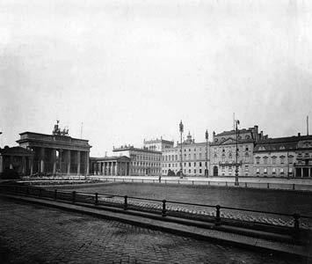
  - Greece
  - Albania
  - Bulgaria
  - Turkey
  - Romania

- This picture is of a square in which city? 1 pt

- What is the world’s most northerly capital city? 1pt

- Name the African nation that is experiencing the worst drought in over 100 years? 1 pt
  - Botswana
  - Namibia
  - Republic of South Africa
  - Mozambique
  - Zimbabwe
- If a Bulgarian nods his head, what is he saying? 1 pt
- What was the first country to recognize the United States of America during the Revolutionary War?
  - Spain
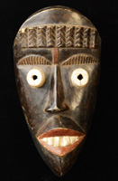
  - France
  - Morocco
  - The Netherlands
- Name one of the two countries in Africa that are home to the Dan people known for their carved wooden masks like the one shown here. 1 pt

- Name one of the modern-day countries with that had significant territory within the Fertile Crescent. 1 pt

- Which agreement/treaty led to the creation of a “single state” for international travel with respect to external border controls for travelers entering and exiting European Union countries, common visas, and with no internal border controls within that “single state”? 1 pt

Score:
Judge:
Possible: 11 pts
ROUND 3

Team: Scribe:
- What is the approximate size of the Earth’s equator? 1 pt
□ 12,500 miles □18,500 miles □ 25,500 miles □ 28,500 miles
- This vine, native to Japan, was brought to America in the 19th century and soon took over large swaths of the nation, especially in the south.. 1 pt
- A UNESCO World Heritage Site, Arz el-Rab is a forest in Lebanon of these type of trees pictured on Lebanon's flag. 1 pt
- Fortune Magazine rated the richest countries in the world per capita of population, based on October 2017 data from the International Monetary Fund. Which European nation rates second-richest after Qatar? 1 pt
- Which of these numbers did the ancient Egyptians consider to be sacred? 1 pt
□ 4 □9 □ 1 □ 5
- Tourism is being developed for this rural area by this world nation because it possesses a large variety of bears and over-active volcanoes. Name this tourist-developing nation with its Kamchatka Peninsula? 1 pt
  - Norway
  - Finland
  - Canada
  - Russia
  - Iceland
- What port on the Strait of Hormuz is home to the main base of the Iranian Navy? 1 pt
- In what year was Greifswald University founded? 1 pt
- In which Province in China is our Sister City Taizhou? 1 pt
- In what country will you find the Great Fence? 1 pt
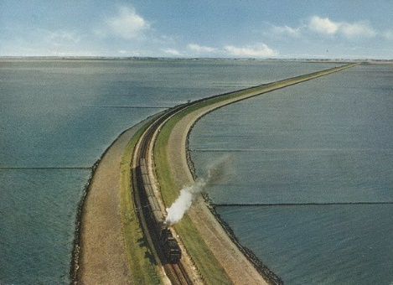
- Each year, the railway in this picture ferries more than 450,000 vehicles over the causeway. The causeway has interrupted the tidal flow, which until its appearance in 1927, had flowed freely between Sylt and the mainland. Name this causeway. 1 pt

Score:
Judge:
Possible: 10 pts
ROUND 4
Team: Scribe:
- What period of Japanese history saw the restoration of imperial rule? 1 pt
- Which two countries combined to form Tanzania? 1 pt
  - Kenya and Zanzibar
  - Malawi and Zanzibar
  - Tanganyika and Zanzibar
  - Tanganyika and Kenya
- Which US state is classified as the only “growing” state in square miles? 1 pt
- Name the desert that Coyotes from Mexico bring illegal immigrants into the USA along the American-Mexican border. 1 pt
  - Atacama Desert
  - Great Salty Desert
  - Patagonia Desert
  - Sonora Desert
- In the 1896 Battle of Adawa, Menelik II, of this nation, led the fight to keep Italian colonizers out of his homeland. 1 pt
- Three of the 5 Civilized Tribes are Cherokee, Chickasaw, and Choctaw. Name one of the other two? 1 pt
- How many countries have a coast on the Baltic Sea? 1 pt
- At its height, 160 cities in 16 countries constituted the Hanseatic League, or Hanse, a trading alliance in the Middle Ages. Name our Sister City that was one of these cities. 1 pt

- Name the nation on the Balkan Peninsula considered to be the most Moslem dominated country in all of central and Eastern Europe. 1 pt
  - Albania
  - Croatia
  - Macedonia
  - Romania
  - Serbia
- Which city is ice free in the winter due to the impact of the warm Gulf Stream or North Atlantic Drift which keeps the area above freezing and it can be used all year round? 1 pt
  - Iqaluit, Canada
  - Murmansk, Russia
  - Odessa, Russia
  - Point Barrow, Alaska
  - Sapporo, Japan

Score:
Judge:
Possible: 10 pts
ROUND 5
Team: Scribe:
- Which African country has the most official languages? 1 pt
- Key West is the southernmost publicly accessible point in Florida. Key West is closer to Cuba than to Miami. How far is Cuba from Key West? 1 pt
- What is the former capital city of Saigon called now? 1 pt
- Geologists agree that this river, which flows by Liege and Namur in Belgium, is the world’s oldest river. 1 pt
- The opal is quite a popular choice for jewelry. Nevada possesses 5% of the world’s supply while this country contains 95% of the world total. Name this country. 1 pt
  - Australia
  - Botswana
  - Democratic Republic of the Congo
  - Guyana
  - Republic of South Africa
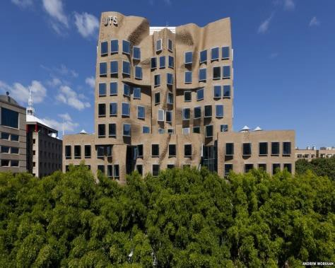
- Name the sport of which FIFA is the governing body.. 1 pt
- The University of Technology Sydney (UTS) Business School, designed by famous Architect Frank Gehry is known by what name? 1 pt

- Which city, built on 118 small islands, is the MOSE project aimed to protect it from rising seawaters. 1 pt

- In 2017, researchers at MIT designed one of the strongest lightweight materials known to man. It has the potential to be 10 times stronger than steel, but much lighter. It is made by compressing and fusing flakes of what material? 1 pt
  - Titanium
  - Diamond
  - Graphene
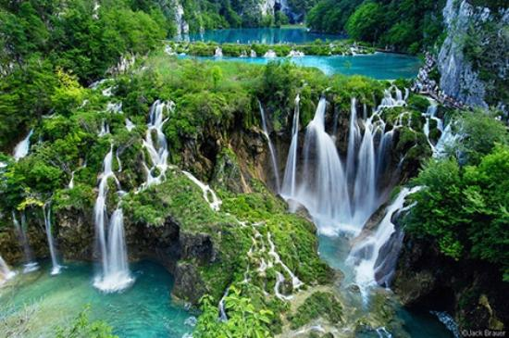
  - Osmium

- In which country is Plitvice Lakes National Park? 1 pt

Score:
Judge:
Possible: 11 pts
ROUND 6
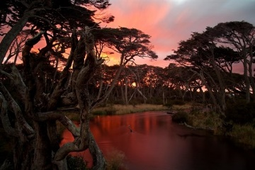
Team: Scribe:

- Name one of the countries that form the archipelago called Tierra del Fuego? 1 pt
- How much bigger than Texas is Alaska? 1 pt
  - ½ as big
  - Same size
  - 1½ times
  - Twice as big
  - 2 ½ times
  - Three times as big
- What statue in Newport News raised a ruckus because it depicts an historic figure with two arms, even though he lost an arm long before coming to Virginia? 1 pt
- The highest mountain in South America is 1 pt
  - Aconcaqua
  - Machu Picchu
  - Tipas
  - Titicaca
- Newport News/Williamsburg International Airport is known by the FAA three letter code, PHF. What do those letters stand for? 1 pt
- Which country in South America is the world's largest exporter of bananas? 1 pt

- What is the name of this fried or baked triangular-shaped snack food made in India of a potato stuffing and usually containing onions and peas served with a mint chutney? . 1 pt

- A new soccer team is coming to the Peninsula and will be playing at the Pomoco Stadium at CNU beginning in May 2018. What is the name of this club? 1 pt
- This city, founded by the Romans, is the oldest city in Germany. 1 pt
- Name one of the common industries between Newport News and St. Nazaire. 1 pt
- In which nation is hurling the national sport? It is played with 15 players per side. 1 pt
Score:
Judge:
Possible: 11 pts
ROUND 7
Team: Scribe:
- England and Wales are two of the countries that form the United Kingdom. They compare in size approximately, using square miles as the measure, to Virginia and a bordering state? 1 pt
  - Virginia and Maryland
  - Virginia and Kentucky
  - Virginia and North Carolina
  - Virginia and Tennessee
  - Virginia and West Virginia
- What is the longest river in Africa? 1 pt
- Though originally called this because it was a center of education and ideas during the Age of Enlightenment, this city - the first city in Europe to do so - introduced lighting in 1828 in a major thoroughfare with gas lamps earning it the nickname "La Ville-Lumière". Name this city
. 1 pt
- In the 2018 Winter Olympic Games, what team was abbreviated to “OAR”?
1 pt
- What is an entrée in a French meal? 1 pt
- The French desert Pain Perdu is made of old bread soaked in a mixture of eggs and sugar then cooked in the oven or fried in a pan. Name this breakfast favorite in the US?
1 pt
- The word “PEZ” comes from the German word for peppermint. Show how this came about through the spelling of the German word. ………………………….………………………………………… 1 pt

- What is the other name for an ice-cream headache?
1 pt

- Which country discovered a bacteria that can break down plastic? 1 pt
- True or False: Cinco de Mayo commemorates Mexican Independence. 1 pt
- Which vegan protein source, made of fermented soybeans, originated in Indonesia?
1 pt

Score:
Judge:
Possible: 11 pts
ROUND 8
Team: Scribe:
- Which European region attempted to secede from its parent country in the past twelve months?
1 pt
- The greatest cause of death in the deserts of the world is one of the following? 1 pt
  - dehydration
  - venomous snake bites
  - drowning in a dried-up river bed (wadi)
  - hypothermia
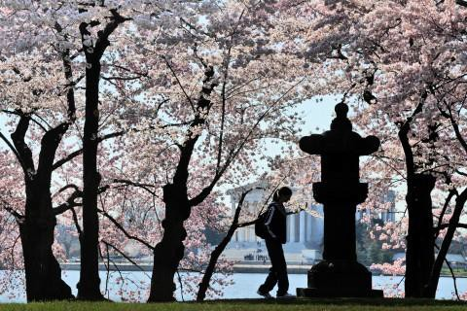
  - starvation due to lack of plant life

- These flowering trees surround the Tidal Basin in Washington DC adjacent to this memorial to a president. Name the monument.
1 pt

- Which of the Sister Cities of Newport News is the farthest South? 1 pt
- In which country did the Industrial Revolution begin? 1 pt
- Who invented the moveable type printing press in Europe? 1 pt
- A marae [muh-RAY] is a sacred meeting space for the people of which country? 1 pt
- What religious practice in Cuba parallels and incorporates the religious beliefs of the Yoruba people of West Africa and Catholicism? 1 pt
- Which crop is found to grow best in the marshes and bogs of the coastal New England states especially Massachusetts? That US state harvests 60% of the US total supply. 1 pt
- This natural product, formed from mattered grasses, is dried and used for burning in many countries of the world such as in Ireland. 1 pt

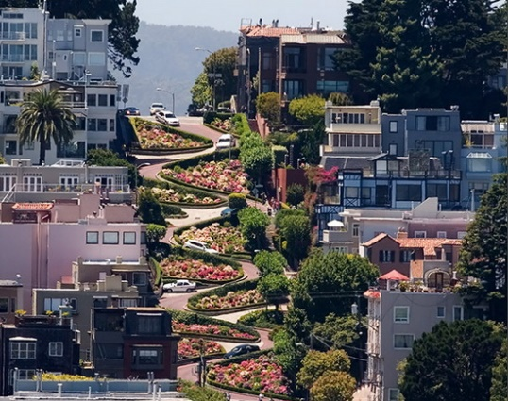
- This crooked section of a street, which is about 1/4 mile (400 m) long, is reserved for one-way traffic traveling east (downhill) and is paved with red bricks. The speed limit in this section is 5 miles per hour (8.0 km/h).In which city will you find this street? 1 pt

Score:
Judge:
Possible: 11 pts
ROUND 9
Team: Scribe:

- This soaring statue of Buddha, along with others, was carved in Sandstone cliffs of which City? 1 pt

- Rock paintings in the Tibesti Mountains suggests the region once had a much wetter climate. This region is occupied by nomadic herders in which desert? 1 pt

- Which Spanish regional capital city hosted the Games of the XXV Olympiad, a city to the South of which is a possible future Sister City for Newport News? 1 pt
- In which country did Nostradamus die in 1566? 1 pt
- The Trans-Dniester region declared independence from this country in 1990, but was never recognized; two thirds of this country’s people are of Romanian descent. Name the country. 1 pt
- Simon Bernard designed the fortification of which fort on the Peninsula? 1 pt
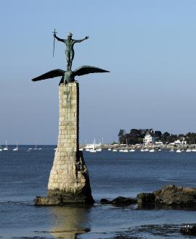

- This monument on the left can be seen in which city related to Sister Cities of Newport News? 1 pt

- In January, 2018 a US state experienced an earthquake off-shore and a tsunami warning was issued. Which state experiences the most earthquakes across America? 1 pt

- If you are invited to dinner in Argentina at 9 pm, at what time should you arrive? 1 pt
- Which set of “folded” mountains within America is considered one of the oldest on earth and are eroding while other ranges of mountains are still growing? 1 pt
- This bag made of thick fabric originated in the 17th century in a town located in the province of Flanders, Belgium
. 1 pt

Score:
Judge:
Possible: 10 pts
ROUND 10
Team: Scribe:
- Which European city do the famous surrealist artists Salvador Dali and Joan Miro come from? 1 pt
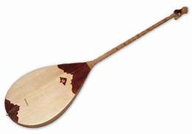

- This instrument originates from which country? 1 pt

- Name the river that Sister City Neyagawa, Japan is located along, and which flows from Lake Biwa into Osaka Bay. 1 pt

- If you spent a day on each island in the Philippines, approximately how long would it take to visit them all? 5, 10, 20, or 25 years 1 pt

- Name this influential architect—known for her buildings’ fluid lines—who designed China’s Guangzhou Opera House and was the first woman to win the Pritzker Architecture Prize (often referred to as architecture’s Nobel).
1 pt
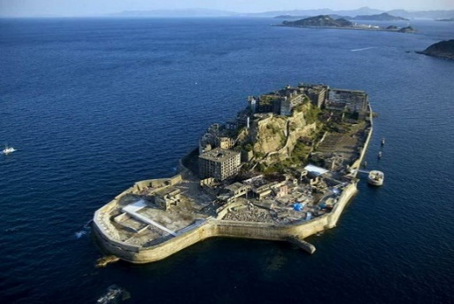
- Name this island, commonly called Gunkanjima, one of 505 uninhabited islands in the Nagasaki Prefecture, some 15 kilometers from Nagasaki itself. Populated from 1887 to 1974 as a coal mining facility, the most notable features are the abandoned concrete buildings and the sea wall surrounding it. 1pt
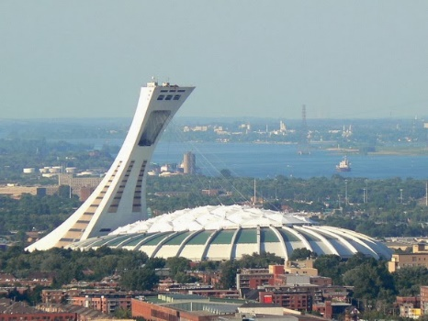
- The White House is the official residence and office of the President of the United States. What other country has a presidential office building called the White House? 1 pt
- Where is this tallest inclined tower in the world at 175 metres (574 ft). Its 45-degree angle is awe-inspiring, especially when you consider that the Leaning Tower of Pisa’s tilt is only 5 degrees. Visitors can reach the top of the tower on a mesmerizing climb in a glass-encased funicular, the only funicular in the world that operates on a curved structure.. 1 pt
- From which country does over 60% of the world's cork come from? 1 pt
- Which member state of the EU has the largest population? 1 pt

